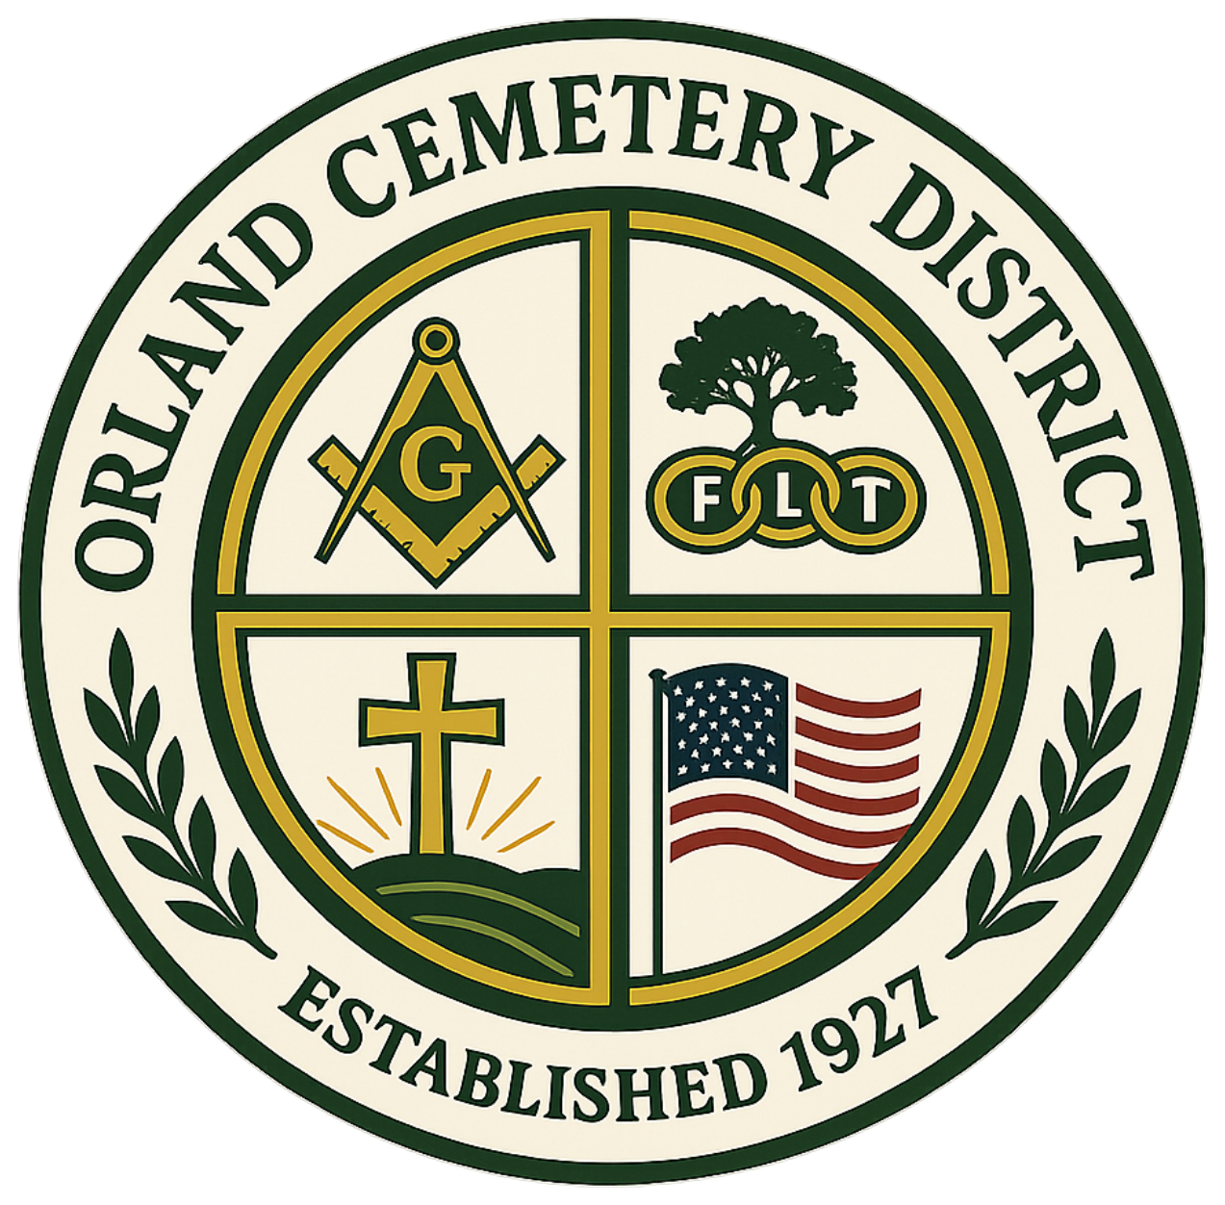

ORLAND CEMETERY DISTRICT
2025–2026 Financial Recap
Fiscal Year July 1, 2025 – June 30, 2026
Prepared for the Board of Trustees
A simple comparison of the District’s adopted budget to year-end actual results.

BUDGET VS. ACTUAL OVERVIEW
Category | Budget | Actual | Variance
Total Income | $643,260.00 | $871,200.67 | $227,940.67 above
Operating Expenses | $704,098.00 | $645,601.20 | $58,496.80 under
Fixed Assets & Other Expenses | $288,395.00 | $220,361.10 | $68,033.90 under
Year-End Net Income / (Loss) | ($349,233.00) | $5,238.37 | $354,471.37 better

REVENUE HIGHLIGHTS — BUDGET VS. ACTUAL
Category | Budget | Actual | Variance
Property Taxes | $399,629.00 | $440,241.40 | $40,612.40
Sales & Services | $172,500.00 | $180,765.46 | $8,265.46
Interest Income | $60,000.00 | $85,807.57 | $25,807.57
Miscellaneous Revenue | $6,600.00 | $15,294.74 | $8,694.74
Auction Proceeds | $0.00 | $21,434.00 | $21,434.00
Long-Term Debt Proceeds* | $0.00 | $124,763.92 | $124,763.92
* Accounting Note: The $124,763.92 in long-term debt proceeds is shown for accounting purposes only and is not regular operating revenue of the District.

EXPENSE HIGHLIGHTS — BUDGET VS. ACTUAL
Category | Budget | Actual | Variance
Salaries & Benefits | $436,528.00 | $388,825.27 | $47,702.73 under
Services & Supplies | $267,570.00 | $233,393.57 | $34,176.43 under
Fixed Assets | $228,400.00 | $200,405.51 | $27,994.49 under
Administrative & Cost Allocation Charges | $19,995.00 | $19,955.59 | $39.41 under
Contingency | $40,000.00 | $0.00 | $40,000.00 under

YEAR-END SUMMARY
The District’s budget anticipated a year-end loss of ($349,233.00), primarily reflecting planned capital and other expenditures. Actual results produced positive net income of $5,238.37. Operating expenses, fixed assets, and other expenses finished below their overall budgeted amounts, while key revenue categories performed above budget.

